**Assignment 1**

1. What is JDK? JRE? JVM?

JDK means java development kit which is the java language software development kit and it’s contains JRE, it’s the environment of the development

JRE means the java runtime environment which is the necessary environment of java development if we just want to run a java application, the JRE is enough

JVM means the java virtual machine is a tool that let the java program to be runnable to every different type a computer if they have JVM

1. What is java compiler?

Java compiler Is javac which is the tool that takes the text file(the program we write) translate is to the language that only the java can read and become the java program

1. Why is java platform independent?

It’s is because of the JVM so the program we write is a text file so when we use the JVM in different type of the computer is source code is same but the excusal code run is different.

1. What is IDE? Why is it important for developers?

The IDE means the integrated Development Environment it’s let the programmer the use a lot of development tool into one GUI, it’s important because it’s increase the production power of the programmer. And let they can customize their own IDE.

1. Is java case sensitive?

Yes the upper and lower case is matter for the java program

1. What do the following key words do?

Static means it’s not object reliable it is for all class

Final means can’t change

Public means can be access by any object

Void means no return type

Null means empty

Package means that let the classes become a one main function

Class means the blueprint of the object

New means create the new object

1. What is primitive type and reference type?

Primitive type means char, int, float, double, short, long, Boolean byte

1. Is parameter passed by value or reference?

value

1. What is the output: System.out.println(1 > 0 : “A”:”B”);

It will be error

1. How to define constants in java?

Use final and capital letter to difference other variables

1. What is String? Is it primitive type?

String is the reference type it’s immutable and thread safe

1. How to check if a String is representing a number?

parseInt(String)

1. Write a program to implement the following activity diagram:

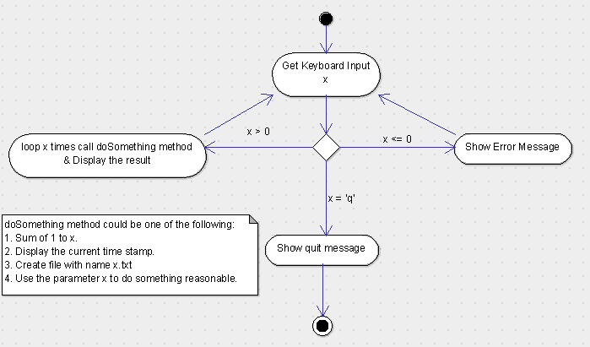

1. Write a program to merge two array of int.

1. Write a program to find the second largest number inside an array of int.

